

uSER MANUAL

By Aaron Burton



Table of Contents

Overview of Budgeting App 2

Hardware Requirements 2

How To Install & Run The Software 2

How To Use The Software 5

Login / Signup 5

Setting your Initial Balance 6

Adding a transaction to your account 7

Viewing Transaction Details 9

Edit Transaction Details 9

Deleting a Transaction 9

Adding a Savings Account 10

Depositing / Withdrawing in a Savings Account 11

Deleting a Savings Account 12

Update Any Account Information 12

How to Quit the application 13

# Overview of Budgeting App

For the deployment of our web application, the user will need to have multiple software applications installed. The user currently for deployment of the web application will need docker desktop set up with a container, along with node.js installed on their system. Following installation, the downloaded zip folder of code will need to be unzipped in the users C: drive folder. Along with DBeaver installed and a Postgres database set up with the SQL code ran on their database schema. The web application Budgeting App, is for the purpose of helping store, manage, and have more control over the end-users’ transactions and savings in everyday life. The user will be able to sign up with an email, login with that email, update their chosen balance, add transactions (income and spending transactions), mange their account settings and manage savings accounts on the web application. The purpose of this app is to help the end-users be more financially independent when it comes to managing their money.

# Hardware Requirements

* A workstation, with windows (VERSION 10 or 11)
* 5GB of free storage
* 8gb of RAM

# How To Install & Run The Software

Let’s start with docker, docker is a software application used for launching and maintaining containers. With this project docker was used to host the server file along with node.js to deploy the application. The user will need to have the docker installed and create a docker container for the application to run on.

Following Docker, the user will then need to install node.js, to run the server-side file “server.js”, it is used primarily for its asynchronous event-driven model.

After which the user will need to have DBeaver installed, set up an account and create a POSTGRES schema database. The user will need to connect the database to the docker container they previously made.  
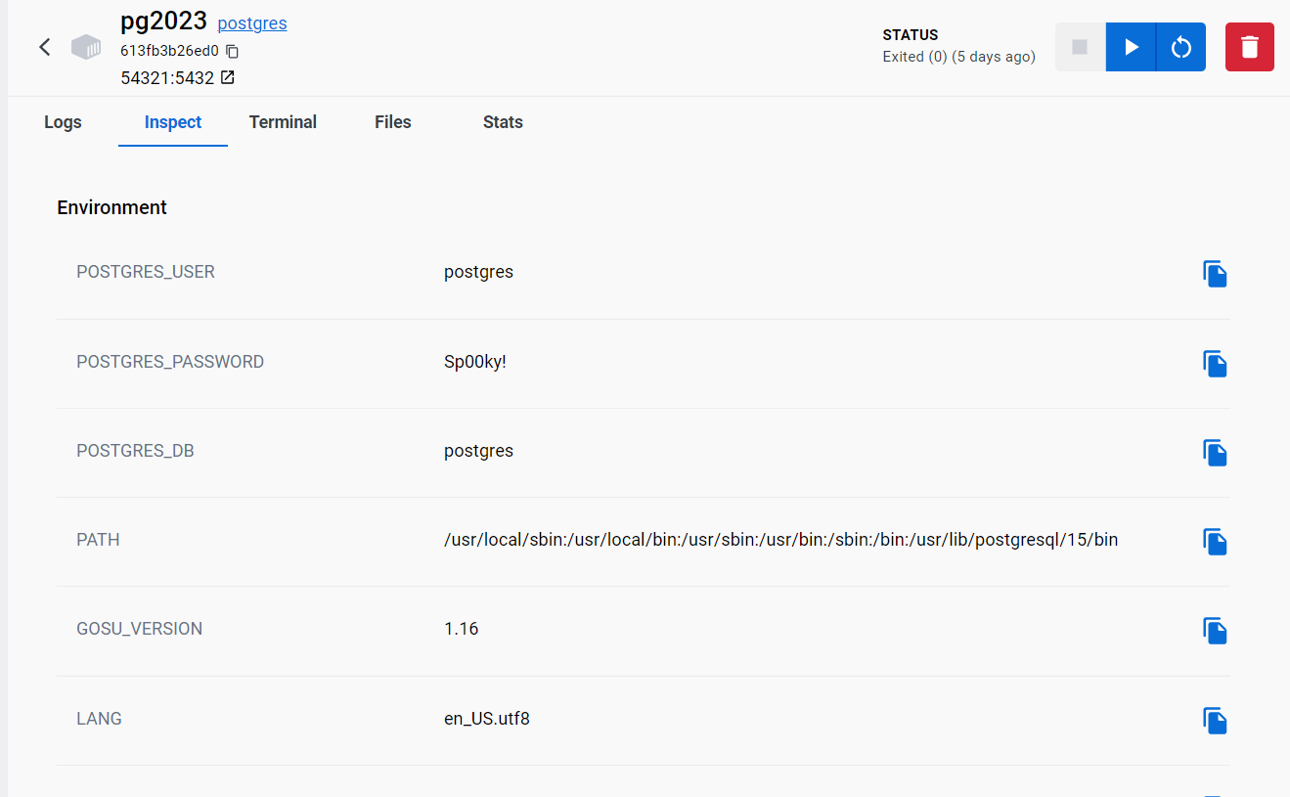  
  
Ensure the connection in the database is the same as the docker container  
  
When the user has created the database, the user will need to enter the SQL file stored along side the code in the submission folder. When ran the user should get no errors except “table does not exist”, the user can just skip these errors.

Now that the user now has the Docker, DBeaver, Node.js, and has the SQL file ran and the folder with the code extracted into their C: drive, the user can now navigate through the code folder to the pages.

TeamsProjectFinalSubmission -> Code -> nodejs -> Budgeting

When in the Budgeting Folder the user will need to click the directory bar and enter cmd.

The user will need to download different small software for this to run. So, type “node server.js”, if you don’t have the certain software installed the command line will inform you of the software missing, so then just type “npm install <Software Name>” e.g. npm install express. Once all the software is installed in the folders location the user will get this message:

Finally, if the user then opens their browser of choice and type “localhost:8081” they will be able to access and interact with the web application.

# How To Use The Software

## Login / Signup

The first thing the user would want to do to access the pages on the web application, is to create an account. The user can do this by clicking the signup button on the nav bar in the top right corner of the page.

When redirected to the signup page the user is prompted to enter the following information, “First Name, Last Name, Date of Birth, Email and password”. When all the relevant information is entered the user will then proceed to click the sign-up button.

If the user already has an account they can login with their email address they signed up with and password.

## Setting your Initial Balance

The user once logged in will need to update the app with their intended balance. For maximum clarity with financial management, it is recommended that you enter the total amount you have currently, don’t worry about other people seeing your amount because the data is stored locally on your device no one is able to connect and see it unless they have access to your device.

To do this the user will need to navigate to the settings page.

When you open the settings page you will be displayed with the information you have entered, when signing up. The user will then need to locate the balance input box and enter their balance and click the save button.

When the changes have been saved the Balance on the home page will be updated.

## Adding a transaction to your account

To add a transaction to your account the user will need to navigate to the transaction page. When at the transaction page the user will need to press the blue plus icon.

When pressed the button will redirect the user to the add transaction form / page. Here you can enter the information related to the transaction you wish to enter. The user can choose the category of transaction, and the type of transaction, then enter the name, price, notes of transaction, location and time of transaction. The user can also upload a picture of the receipt of the transaction. Most of these inputs for information is optional, the only information the user will need to enter for a transaction is category, type, name, and price. Also if the user does not enter a time of transaction, the application will automatically set the time to the time of submission. Once all the information is entered the user can click submit to add the transaction to their account.

After the transaction has been submitted it will be displayed on the transaction page and recent transactions on the Home page.

## Viewing Transaction Details

If the user will like to view their transaction details they will need to navigate to the transaction page. Once there the user will need to click the 3 dots option button next to the transaction they wish to see further details on. Once clicked the user will need to click “View”. This will direct the user to a separate page to view the transaction details.

## Edit Transaction Details

Similar to viewing the transaction the user will need to click the edit option next to the transaction. When the user clicks “Edit” the same form will pop up with the entered information of transactions as given when the user added the transaction. The user can change any of the information here and save the changes.

## Deleting a Transaction

The same way the user views and edits the transaction, the user can also select the “Remove” option to remove the transaction from their account.

## Adding a Savings Account

To add a savings, account the user can navigate to the “Savings” Page. Here they will see a mostly empty page with a drop-down menu to select a savings account and enter an amount to either deposit or withdraw.

To add an account the user, need to press the green “Add Account” button. After which they will be presented with a form to enter to create a saving account linked to the users account with the information they provide.

After the user enters the required information and click submit, the savings account will be created and displayed on the savings page.

The user is able to have multiple savings account, and all will be displayed on the page.

## Depositing / Withdrawing in a Savings Account

If a user wishes to deposit or withdraw from their savings account they can user the drop-down menu to select a Savings Account and enter the amount they wish to deposit or withdraw.

**Depositing Withdrawing**

## Deleting a Savings Account

If the user decides to not want the savings account for any reason they can select the savings account they wish to delete and click the “Delete Savings” button.



## Update Any Account Information

If the user entered a bit of information incorrectly when signing up or want to change their password, the user can navigate to the settings page and change any of the information in the boxes to update their account by clicking on “Save Changes” button.

# How to Quit the application

At any point the user wishes to logout they can press the Logout button on the nav bar on the top right of the screen.

But to close the system, the user will have to go their command prompt they used to run the server.js file and press Crtl + C.

This will shutdown the server file. The user can then proceed to stop the Docker Container as well.

The user can also just stop the docker container and that will close the server file from being running and logout the user.